Haplogroup Dynamics in Afghanistan: A Genetic History from the Neolithic to the Steppe Migrations
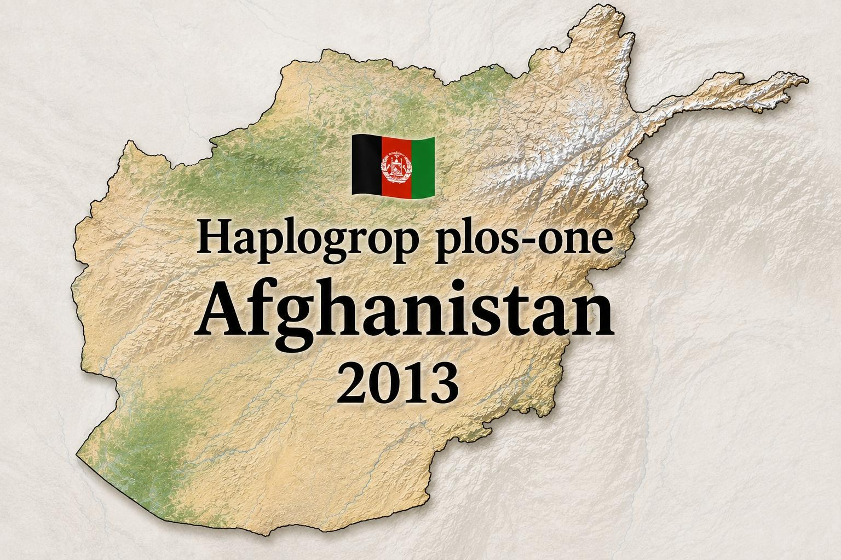
Abstract

This paper presents a comprehensive analysis of Y-chromosomal haplogroup distributions among the five major ethnic groups of Afghanistan—Hazara (Āzrah), Pashtun, Tajik, Uzbek, and Turkmen—based on peer-reviewed genetic studies published in PLOS ONE (Haber et al. 2012; Di Cristofaro et al. 2013). The data reveals that all Afghan populations share a common Neolithic ancestral substrate that emerged during the agricultural revolution (10,000–7,000 years ago). Inter-ethnic differentiation began during the Bronze Age (circa 4,700 years ago), driven by the formation of regional civilizations. Subsequent migrations—including steppe pastoralists, Iranian tribes, Arabs, Mongols, and Turco-Mongol expansions—were differentially assimilated by each ethnic group. The Hazara exhibit the highest frequency of East Asian-related haplogroup C3-M217 (33.3%), consistent with documented Mongol influence, but they also retain a significant Neolithic Iranian substrate (J2a1-Page55 at 13%). The Pashtun and Tajik populations are characterized by high frequencies of R1a1a-M17 (51% and 30.4%, respectively), traditionally associated with steppe migrations, although the presence of South Asian-specific lineages (L-M20, H-M69, R2a-M124) suggests a more complex pattern of gene flow from the Indus Valley. This paper argues that the genetic architecture of Afghanistan is best understood as a palimpsest of overlapping layers, where no single ethnic group is "pure" or "original," but each carries a unique mosaic of the region's deep history.

---

1. Introduction

Afghanistan has served as a crossroads of human migration and cultural exchange since the Paleolithic. Its location at the intersection of Central Asia, South Asia, and the Middle East has made it a conduit for successive waves of population movements: Neolithic farmers from the Fertile Crescent, Bronze Age pastoralists from the Eurasian steppe, Iranian tribes, Hellenistic armies, Arab conquerors, Turkic dynasties, and Mongol invaders. Each of these events left a genetic imprint on the modern population, but the extent to which these imprints have been assimilated varies significantly across ethnic groups.

This paper synthesizes raw genetic data from two landmark studies—Haber et al. (2012) and Di Cristofaro et al. (2013)—to provide a detailed comparative analysis of haplogroup frequencies among the five major ethnic groups of Afghanistan: Pashtun, Tajik, Hazara, Uzbek, and Turkmen. The objective is to document the layered genetic history of these populations, tracing their origins from the Neolithic substrate through the Bronze Age differentiation to the historical migrations that shaped their modern genetic profiles.

---

2. The Neolithic Substrate: A Common Heritage

2.1. The Common Ancestral Population

Both Haber et al. (2012) and Di Cristofaro et al. (2013) converge on a fundamental conclusion: all current Afghans largely share a heritage derived from a common unstructured ancestral population that emerged during the Neolithic revolution (approximately 10,000–7,000 years ago) and the formation of the first farming communities. This Neolithic substrate is the foundation upon which all later layers have been superimposed.

2.2. Haplogroups of the Neolithic Farmers

The Neolithic component in Afghanistan is primarily associated with haplogroups that originated in the Zagros Mountains and the Fertile Crescent, expanding eastward with the spread of agriculture:

· J2a1-Page55 (13% in Hazara, 11% in Tajik, 3% in Pashtun): This haplogroup is a genetic signature of the Neolithic Iranian farmers who first settled the Helmand Basin, Shahr-e Sukhteh, and Mundigak (circa 3300–2350 BCE). Ancient DNA from Shahr-i Sokhta confirms the presence of J2a1a1b1a1a at 2600–2500 BCE, establishing a 4,500-year continuity. The Hazara exhibit the highest frequency of J2a1-Page55 among all Afghan populations (13%), suggesting that they have retained more of this Neolithic substrate.
· G2-M201 (7.9% average in Afghan gene pool): This haplogroup is associated with the Neolithic expansion from the Near East and is found at high frequencies in the Caucasus. In Afghanistan, sub-lineage G2c-M377 is the second most frequent haplogroup in the south (6.2%) but is substantially lower in the north (2.3%).
· L-M20 (9.5% in Afghanistan): This haplogroup is considered autochthonous to South Asia and is associated with the Neolithic populations of the Indus Valley. It exhibits substantial disparity in its distribution on either side of the Hindu Kush range, with 25% of northern Afghans belonging to this lineage, compared with only 4.8% of males from the south.

---

3. Bronze Age Differentiation

Haber et al. (2012) employed BATWING analysis to estimate the time of population splits and concluded that inter-Afghan differentiation started during the Bronze Age, approximately 4.7 kya (95% CI 2,775–7,725), probably driven by the formation of the first civilizations in the region. These include the Bactria-Margiana Archaeological Complex (BMAC, 4300–3700 ya) and the Indus Valley Civilization (5300–3800 ya). During this period, the common ancestral population began to differentiate into the social and economic systems—sedentary farmers, herders, and city-dwellers—that would later evolve into the modern ethnic groups.

---

4. The Steppe Pastoralist Layer: R1a1a-M17

The haplogroup most frequently associated with the steppe migrations is R1a1a-M17. However, the Afghan data reveals a more complex pattern than a simple "steppe invasion" narrative:

4.1. Population-Specific Frequencies

Ethnic Group R1a1a-M17 Frequency
Pashtun 51.02%
Tajik 30.36%
Uzbek 17.65%
Hazara 6.67%

The Pashtun and Tajik populations exhibit the highest frequencies of R1a1a-M17, which aligns with the historical association of these groups with Iranian-speaking populations that may have been influenced by steppe pastoralists. However, the data does not support a direct expansion from the Pontic Steppe, as the sub-lineage R1a1a7-M458—common in eastern Europe—is absent in Afghanistan. The highest diversity of R1a1a-M17 is found among populations of the Indus Valley, suggesting that this lineage is more deeply rooted in South Asia than previously thought.

---

5. The Mongol Layer: C3-M217 and East Asian Admixture

The haplogroup most strongly associated with the Mongol invasions is C3-M217 (C-M130), which is predominantly found in East Asia and Central Asia:

5.1. Population-Specific Frequencies

Ethnic Group C3-M217 Frequency
Uzbek 41.18%
Hazara 33.33%
Tajik 3.57%
Pashtun 2.04%

The Hazara and Uzbek populations exhibit significantly higher frequencies of C3-M217 than other Afghan groups, consistent with their documented historical connections to the Mongols and Turco-Mongol expansions. The Hazara oral tradition of descent from Genghis Khan's army is reflected in their genetic profile, but the presence of J2a1-Page55 (13%) and G2 in Hazaras indicates that the Mongol component is a layer, not a foundation. The Hazara population carries the Neolithic Iranian substrate (J2a1) and the Mongol admixture (C3) in a unique combination that distinguishes them from other Afghans.

---

6. Regional Patterns of Genetic Diversity

6.1. The Afghan-Indian Affinity

The Pashtun and Tajik populations show a significant genetic affinity to populations from North and West India, marked by the presence of Indian lineages L-M20, H-M69, and R2a-M124, as well as high frequencies of R1a1a-M17. This affinity suggests interactions that could have existed since the establishment of the region's first civilizations at the Indus Valley and the BMAC.

6.2. The Hazara-Uzbek Cluster

The Hazara and Uzbek populations are genetically distinct from the Pashtun-Tajik cluster, showing more affinity to East Asian and Central Asian populations due to their higher frequencies of C3-M217. Barrier analysis separates the Hazara and Uzbek from the Pashtun, Tajik, and Indian populations, creating groups with less variation within them and more variation among them.

6.3. The Turkmen

The Turkmen, a Turkic-speaking group, have not been extensively analyzed in the same depth as the other four groups in the available studies. However, as a Turkic-speaking population with historical roots in the Oghuz confederation, they are likely to share similarities with the Uzbek but with their own distinctive admixture patterns.

---

7. Discussion

7.1. The Layers of Afghan Genetic History

The genetic data from the Afghan ethnic groups reveals a layered history that can be summarized as follows:

Layer Time Period Key Haplogroups Ethnic Impact
Neolithic Substrate 10,000–7,000 ya J2a1, G2, L-M20 Common heritage shared by all Afghans
Bronze Age Differentiation ~4,700 ya (Formation of cultural structures) Pashtun split first, followed by others
Steppe Pastoralist Influence Late Bronze / Iron Age R1a1a-M17 Strongest in Pashtun and Tajik
South Asian Gene Flow Ancient & Historical L-M20, H-M69, R2a-M124 Marked in Pashtun and Tajik
Mongol & Turco-Mongol 13th–16th CE C3-M217, Q-M242 Strongest in Hazara and Uzbek

7.2. The Hazara (Āzrah) Position

The Hazara present a unique case: they carry the highest frequency of Neolithic Iranian haplogroups (J2a1-Page55 at 13%), but also the highest frequency of East Asian/Mongol haplogroups (C3-M217 at 33.3%). This dual heritage makes them the most genetically layered of all Afghan groups. The Mongol contribution is an admixture, not a foundation—the Neolithic Iranian substrate predates the Mongol invasions by over 3,000 years.

7.3. The Pashtun and Tajik Position

The Pashtun and Tajik populations are characterized by high frequencies of R1a1a-M17, traditionally associated with steppe pastoralists. However, the absence of the European-specific sub-lineage M458 and the presence of high diversity in the Indus Valley suggests that the R1a1a-M17 in Afghanistan is not a product of a recent steppe migration but may be rooted in the Bronze Age populations of the region.

---

8. Conclusion

The Y-chromosomal data from Afghanistan, as presented in the PLOS ONE studies, documents a layered genetic history:

1. Neolithic Substrate: All Afghans share a common heritage derived from the Neolithic revolution and the formation of the first farming communities.
2. Bronze Age Differentiation: Inter-ethnic differentiation began during the Bronze Age, driven by the formation of regional civilizations.
3. Steppe Influence: The R1a1a-M17 lineage in Pashtuns and Tajiks is not a simple "steppe invasion" but a more complex phenomenon rooted in Bronze Age populations of the Indus Valley.
4. Mongol Layer: The C3-M217 haplogroup in Hazaras and Uzbeks represents a late (13th century CE) admixture, not a foundation.
5. No "Pure" Population: All Afghans are mosaics of these layers, and no single ethnic group is "original" or "pure." The genetic diversity of Afghanistan is a product of its position as a crossroads of civilizations.

---

9. References

1. Haber, M., Platt, D. E., Ashrafian Bonab, M., et al. (2012). Afghanistan's Ethnic Groups Share a Y-Chromosomal Heritage Structured by Historical Events. PLOS ONE, 7(3): e34288.
2. Di Cristofaro, J., Pennarun, E., Mazières, S., et al. (2013). Afghan Hindu Kush: Where Eurasian Sub-Continent Gene Flows Converge. PLOS ONE, 8(10): e76748.
3. Narasimhan, V. M., et al. (2019). The formation of human populations in South and Central Asia. Science, 365(6457): eaat7487.
4. Whale, J. (2012). Y-Chromosomal and Mitochondrial DNA Analysis of the Afghan Populations. MPhil Thesis, University of Portsmouth.
License: CC BY-SA 4.0

"Afghanistan's genetic history is not a story of 'pure' races but a palimpsest of overlapping migrations—each layer adding to a mosaic that reflects the region's position as the crossroads of Asia."

